1. Grade Checker

Take a score as input and print the grade based on the following:

90+ : "A"

80-89 : "B"

70-79 : "C"

60-69 : "D"

Below 60 : "F"

here we used a basic if else statement to carry out marks and all.

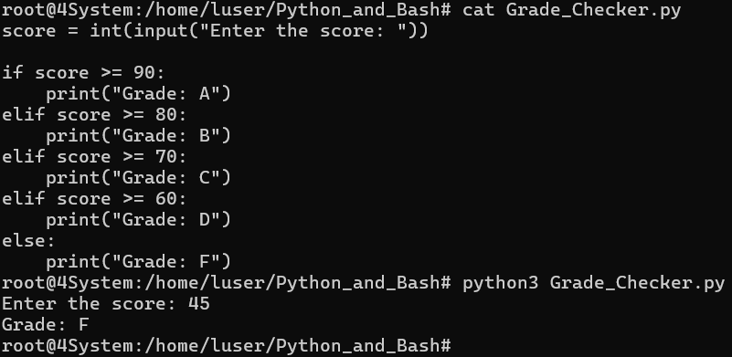

The program asks the user to enter a score and checks the range to print the corresponding grade using simple if-else statements.

2 Student Grades

Create a dictionary where the keys are student names and the values are their grades. Allow the user to:

Add a new student and grade.

Update an existing student’s grade.

Print all student grades.

Used dictionary and basic operations. Using if else:

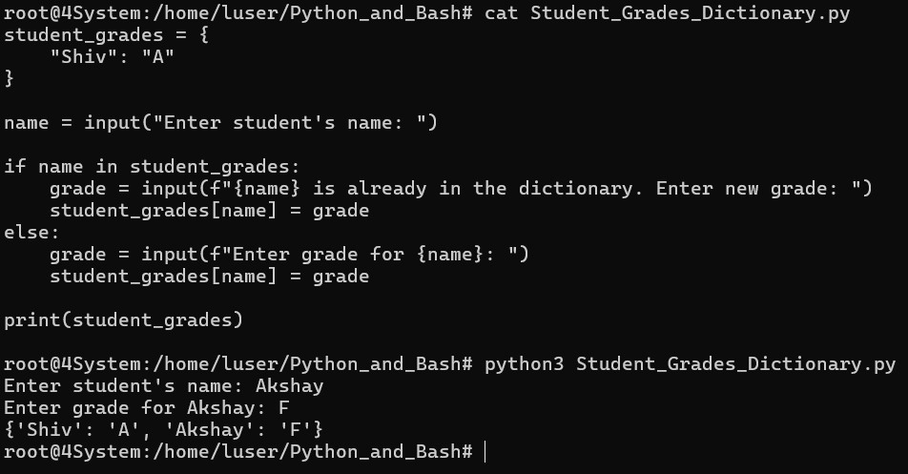

The dictionary already has **Shiv** with grade **A**.

The program asks for a student's name.

**If-else**:

* If the student already exists, it asks for a new grade and updates it.
* If the student doesn't exist, it adds them with the grade entered.

It prints the **updated dictionary** with all students and grades.

3.Write to a File

Write a program to create a text file and write some content to it.

Using file functions like write and open.

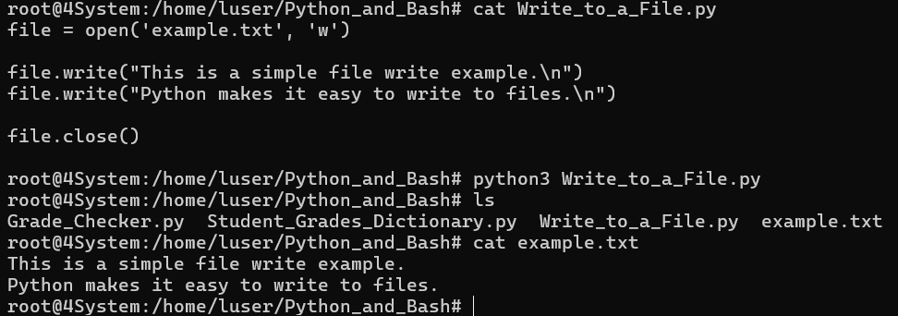

**open('example.txt', 'w')** opens the file for writing.

**file.write()** writes the content to the file.

**file.close()** manually closes the file after writing.

4. Read from a File

We used open in read mode and file.read to read and print to display.

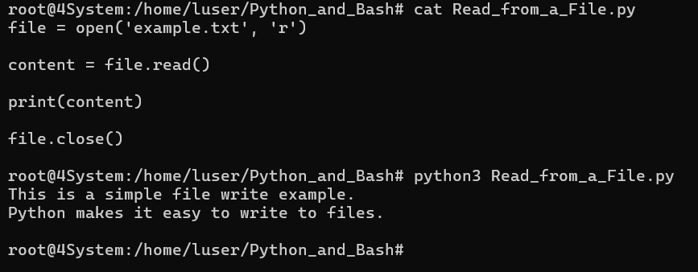

**open('example.txt', 'r')**: Opens the file in **read mode**. If the file doesn’t exist, it will raise a FileNotFoundError.

**file.read()**: Reads the entire content of the file and stores it in the content variable.

**print(content)**: Displays the content of the file on the screen.

**file.close()**: Closes the file after reading it.

**Submission Guidelines -:** Attach Screenshots or command along with explanation and submit in doc(google doc or microsoft doc) format or share github link